 | Online Blood Bank System  Technical Design Document  1.0
 | Prepared By / Last Updated By | Reviewed By | Approved By
Name | Rajat Bishnoi | Asheesh Sahu
Role | Team Member | Team Member
Signature
Date

Table of Contents

1.0 Introduction 3
1.1 Purpose of this document 3
1.2 Scope 3
1.3 Intended Audience 3
1.4 Definition & Acronyms 3
2.0 Conventions and Standards Followed 4
3.0 Assumptions, Dependencies and Risks 4
3.1 Assumptions: 4
3.2 Dependencies: 4
4.0 Schematic Diagram 4
5.0 Use Case Realization 5
5.1.1 User Registration 5
a. Functional Requirement 6
b. UI Validations 6
c. UI Controls 7
d. UI Methods Definition 8
e. UI Design 9
6.0 Database Design 10
6.1 Data Model 10
6.2 Tables Structure 10

Introduction

Purpose of this document
The purpose of the detail design document is to define the detailed design for all the components of Patient Health Management system that are specified in the Business Requirement/Use case document. All the low level components, interfaces and integrations are detailed out in this document.

Scope
This sub-section shall state the scope of this detailed design document
• Create and maintain user information.
• Create and maintain Blood Donation information.
• Create and maintain User Login information.
• Create and maintain Blood Donation information.
• Create and maintain Blood Availability information.
• Create and maintain Slot Availability information.
• Create and maintain Feedback information.
• Create and maintain Requirement List information.

Intended Audience
The intended audience for this document are
- Developers, testers, other associates in the project
- Technical lead, Scrum Master
- Product Owner

Definition & Acronyms
Acronyms | Definitions
OBBS | Online Blood Bank System

Conventions and Standards Followed
The modules under scope needs to adhere to the coding standards and guidelines


Assumptions, Dependencies and Risks

Assumptions:
- Once the application is built the ONLINE BLOOD BANK SYSTEM will manually load the user registration, slot booking, blood donation, feedback and blood availability table into the system.
- There will be no concurrent users for the application. The Patient profile will be maintained by the User.
- Any changes to the design mentioned in the BRD would be taken as a Change Request

Dependencies:
- Availability of database design characteristics & access shall be defined by the
- Resource availability throughout each of the sprint

Schematic Diagram
A schematic, or schematic diagram, is a representation of the elements of a system using abstract, graphic symbols rather than realistic pictures. It gives an overview of overall system
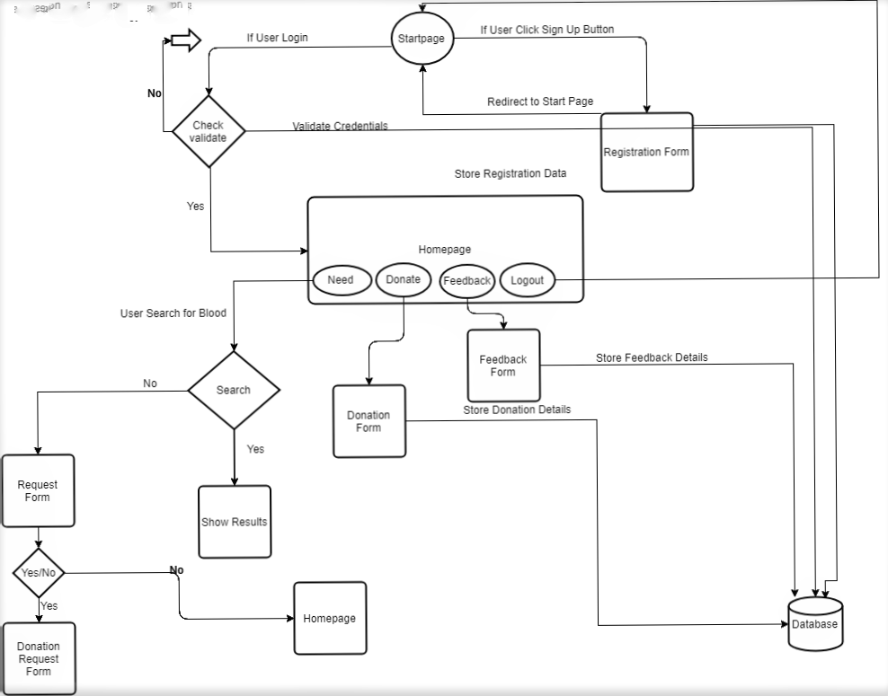
Data Flow Diagram of Online Blood Bank System

Use Case Realization

User Registration
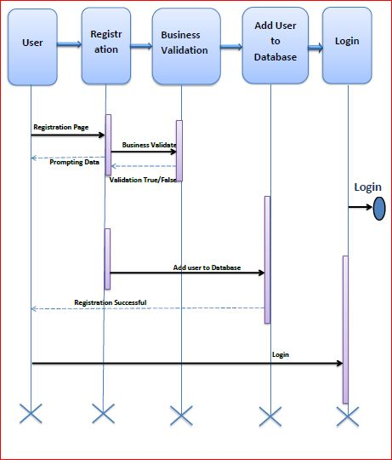

Functional Requirement
. Login Page checks the authentication of the user and based on his role, directs the user to the respective page. User will provided with Add Patient, Details, Regulation and Search regulation pages and the same user will allowed to see Diagnosis Reports and patient vital parameters reports

UI Validations
Please refer to the below requirements for field level validations:

- All fields are mandatory.
Password should have minimum 8 chars and max 15 chars, space & can contain special characters (ex !,@,#,%,*,& etc.)
- The Email ID format must be checked.
- Phone Number must be of 10 digits’ length
- Age should be between 18 to 65.
- First Name, Last Name, State, Area should contain only alphabets.
- Pin code should be of 6 digits and contain only numbers.
- Weight field should contain only numerical digit.

UI Controls
- Login Page
# | UI Component | Type | Name | Details
1 | Email | email | username | To enter email id.
2 | Password | Password | Password | To enter password.

- Registration Page

# | UI Component | Type | Name | Details
1 | Email | Email | Email | To enter email Id.
2 | Password | Password | Password | To enter password
3 | First Name | Firstname | First | To enter first name.
4 | Last Name | Lastname | Last | To enter last name.
5 | Contact Number | Contactno | Contact | To enter contact details.
6 | Blood Group | Select | Bloodgroup | To select blood group.
7 | State | Select | State | To select state.
8 | Area | Select | Area | To select area.
9 | Pincode | Pincode | Pincode | To enter pincode.
10 | Gender | Select | Gender | To select gender.
11 | Age | Age | Age | To enter the age.
12 | Weight | Weight | Weight | To enter weight.

- Blood Availability

# | UI Component | Type | Name | Details
1 | Blood Group | Select | Bloodgroup | To select blood group.
2 | State | Select | State | To select state.
3 | Area | Select | Area | To select Area.
4 | Pincode | Pincode | PIncode | To enter pincode.

- Add Requirement

# | UI Component | Type | Name | Details
1 | Blood Group | Select | Bloodgroup | To select blood group.
2 | State | Select | State | To select state.
3 | Area | Select | Area | To select Area.
4 | Pincode | Pincode | PIncode | To enter pincode.
5 | Contact | Contact | Contact | To enter contact number.

- Donator Information

# | UI Component | Type | Name | Details
1 | Blood Group | Select | Bloodgroup | To select blood group.
2 | State | Select | State | To select state.
3 | Area | Select | Area | To select Area.
4 | Pincode | Pincode | PIncode | To enter pincode.
5 | Contact | Contact | Contact | To enter contact number.

- Donation Slot Booking

# | UI Component | Type | Name | Details
1 | Hospital Name | Text | Hospitalname | To enter hospital name.
2 | City | Select | City | To select the city.
3 | Time | Select | Time | To select Time.
4 | Date | Date | Date | To select date.

- Feedback Form

# | UI Component | Type | Name | Details
1 | Hospital Name | Text | Hospital | To enter hospital name.
2 | City | Select | City | To select the city.
3 | Feedback | Text area | Feedback | To enter the feedback comments.

UI Methods Definition
Method Name | Parameter | Details
SignUp_Button_Click | Firstname,lastname,bloodgroup,weight,  age,gender,state,area,email,pincode,contactno  password | Allows the user to register.
Login_Button_Click | EmailId,Password | Allow user to login on portal and redirect to homepage.
Need_Button_Click | None | Need button allow user to search for the blood availability in specific area.
Donate_Button_Click | None | A user willing to donate blood can look for the Blood requirement posting and show interest
About_Buttton_Click | None | Show the details about project developer.
Feedback_Button_Click | Hospitalname,city,description | Allow user to give the feedback about the hospital
Logout_Button_Click | None | Logout the user.
Search_Button_Click | Bloodgroup,state,area,pincode | User can check for the specific blood in their state.
SubmitButton_Click | Bloodgroup,state,area,pincode,contactno | To store the details to the database.
Slot_Book_Click | Hospitalname,city,date,time | To store the details to the database.
Yes_Button_Click | None | Allow the user to request for blood.
No_Button_Click | None | User redirect to the homepage

UI Design
Here is a prototype on how the homepage should look like.

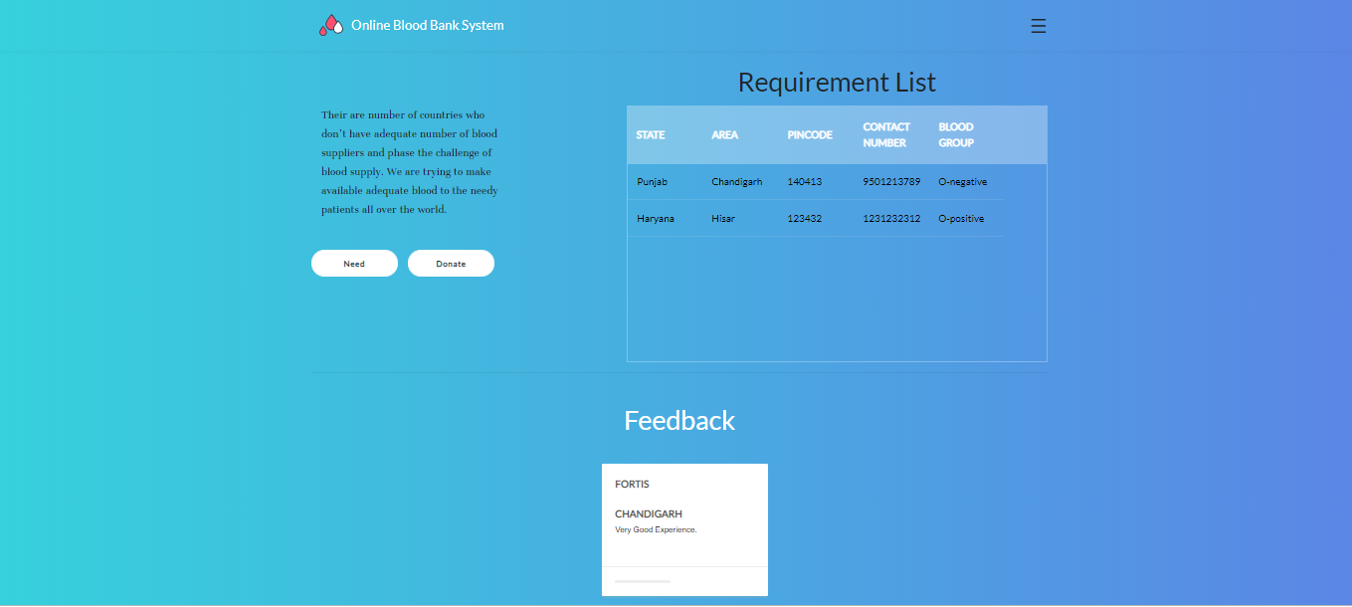

Here is a prototype on how the ‘Blood Availability form’ page should look like.

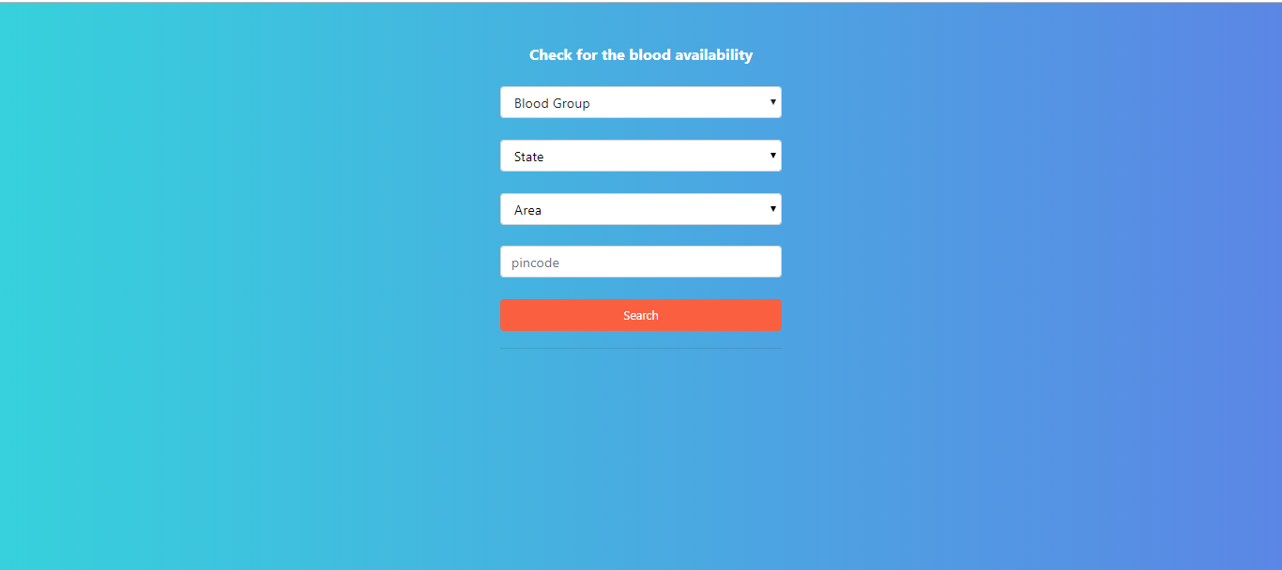

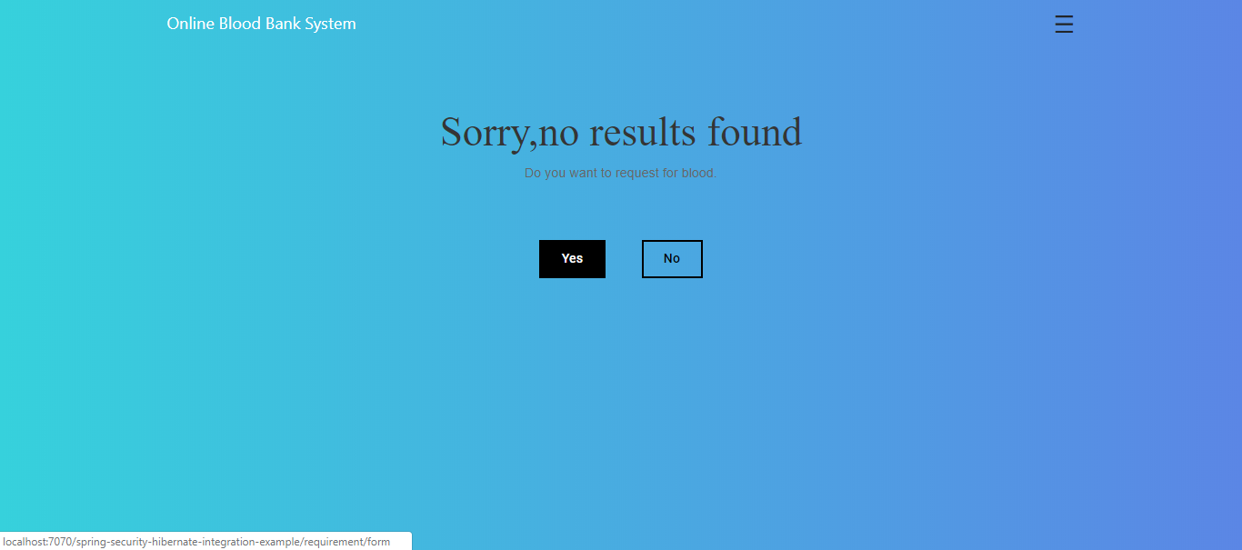

Here is a prototype on how the ‘Requirement Posting Form’ page should look like.

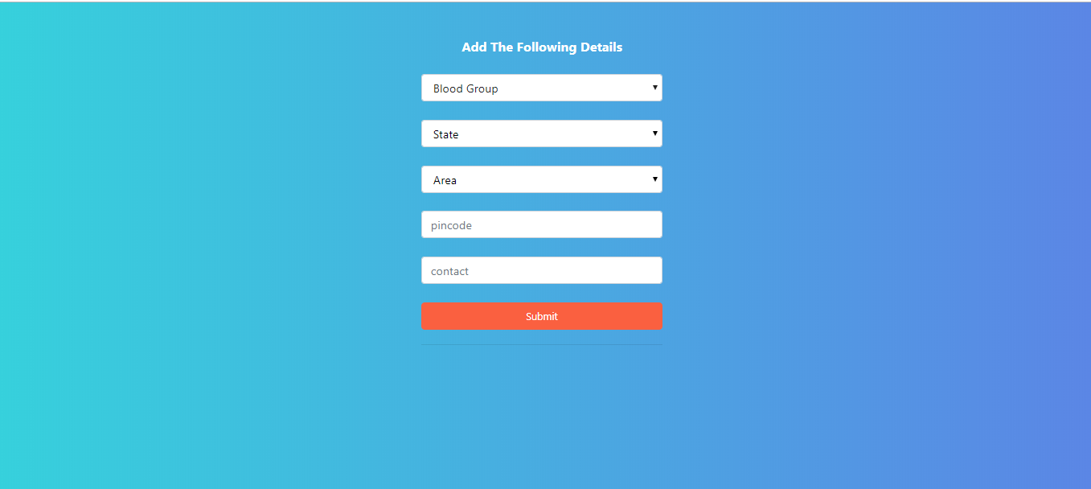

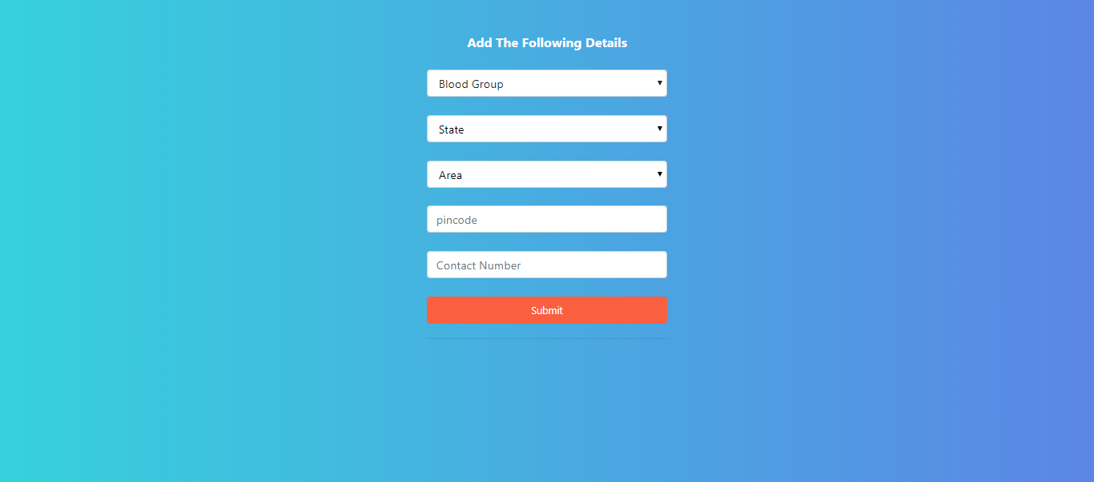

Here is a prototype on how the ‘Slot Booking Form page should look like.

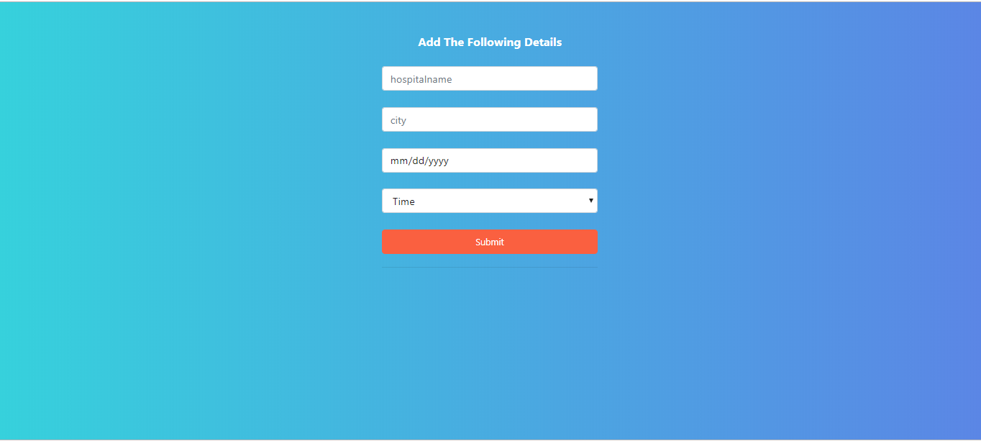

Database Design

Data Model

The following is a schematic view of the database design
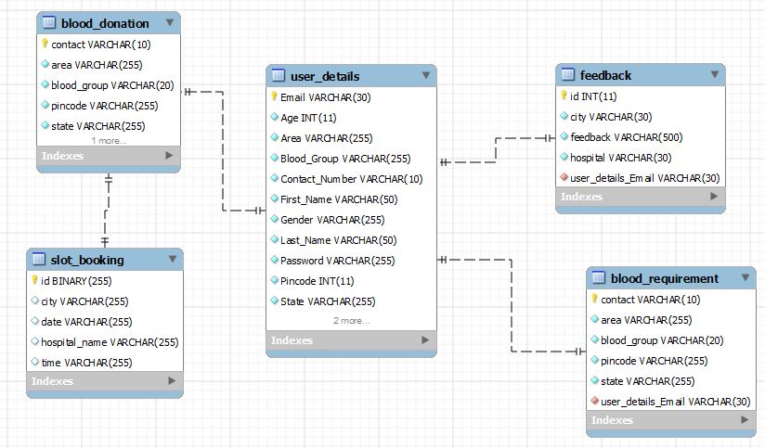

Tables Structure
User Registration:
Field Name | Field Type | Data Type | Mandatory | Possible Values
First Name | Text(50) | Alphabetic | Yes
Last Name | Text(50) | Alphabetic | Yes
Age | Numeric(2) | Numeric | Yes
Gender | Drop Down | NA |  | Male, Female
Contact  Number | Text(10) | Numeric | Yes
Email | Text(15) | Email | Yes
Password | Text(15) | Alphanumeric | Yes
Weight | Numeric(3) | Numeric | Yes
State | Drop Down | NA | Yes
Area | Drop Down | NA | Yes
Pin code | Numeric(6) | Numeric | Yes
Blood Group | Drop Down | NA | Yes | All possible blood groups

User login:
Field Name | Field Type | Data Type | Mandatory | Possible Values
Email ID | Text(15) | Email | Yes
Password | Text(15) | Alphanumeric | Yes

Blood Availability and Donation:
Field Name | Field Type | Data Type | Mandatory | Possible Values
Blood Group | Drop Down | NA | Yes | All possible blood groups
State | Drop Down | NA | Yes
Area | Drop Down | NA | Yes
Pin code | Numeric(6) | Numeric | Yes
Contact  Number | Text(10) | Numeric | Yes

Blood Requirement Posting:

Field Name | Field Type | Data Type | Mandatory | Possible Values
Blood Group | Drop Down | NA | Yes | All possible blood groups
State | Drop Down | NA | Yes
Area | Drop Down | NA | Yes
Pin code | Numeric(6) | Numeric | Yes
Contact  Number | Text(10) | Numeric | Yes

Blood Slot Booking:

Field Name | Field Type | Data Type | Mandatory | Possible Values
Hospital  Name | Text(15) | Alphabetic | Yes
City | Text(15) | Alphabetic | Yes
Date | Drop Down | NA | Yes
Time | Drop Down | NA | Yes

Feedback:
Field Name | Field Type | Data Type | Mandatory | Possible Values
Hospital  Name | Text(15) | Alphabetic | Yes
City | Text(15) | Alphabetic | Yes
Feedback Comments | Text(500) | Alphabetic | Yes

